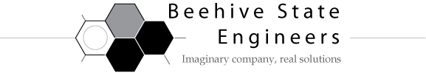

**MEMORANDUM**

**DATE: November 13, 2009**

**TO: Laboratory Group B**

**Steven Klekas, Mitchell McDonald, Raphael Erickson**

**FROM: Tony Butterfield**

**Engineering Training Supervisor**

**SUBJECT: Distillation Column**

Our distillation column is still relatively new, and it has some issues in need of address. I would like you to use a feed solution of IPA and water (25 vol% IPA) in order to better characterize the column.

Please determine the time it takes, from a cold start up, to reach steady state with top products 85% of the maximum possible IPA purity. Under these conditions, determine the plate efficiency of the column.

We are also hoping to eventually implement control of this system. From that steady state condition, please introduce a step change in the reflux ratio and observe the response of column temperatures and tops composition. If each temperature response is modeled as being the result of a first order system plus a time-delay, determine the appropriate Cohen-Coon PID parameters we should use for each, if we were to eventually implement control.

Lastly, we’ve recently discovered a problem with our new distillation column. The decanter, as you will notice, is unable to drain about a centimeter of liquid, leaving a significant volume to mix with the tops of the next distillation run (the last run with this column used a similar feed solution, 20 vol% IPA). We are considering whether or not we should dismantle the decanter and remedy the problem. To better inform our decision, please describe the degree to which this volume could affect your results, and under what circumstances we should be most concerned?

Please contact me with any questions you may have, and I look forward to meeting with you regarding this project on or before Wednesday, November 18, 2009.